ITEC 715 Less is More
When you are writing text for on-screen display in an e-learning project, you usually have a very limited amount of space. Fitting your text into that space can be a challenge. Fortunately, tightening up your wording not only improves your chances of being able to fit your prose into the limited screen space, but also tends to improve the clarity of your writing.

Here is an example I pulled from a publicly-available demo course that GeneEd, Inc. has posted to its web site. It’s hard to believe that anyone would willingly post writing this poor as an example for clients to see! Worse still, this is the sort of text that is typically part of a boilerplate page that explains how the course navigation works, and as such it might be used in every course the company produces. Oh my. You can and will do better in this class. Still, it can be instructive to look at this text in some detail.

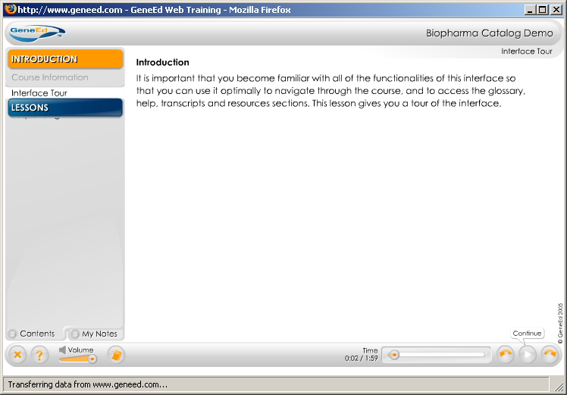Example 1: “It is important that you become familiar with all of the functionalities of this interface so that you can use it optimally to navigate through the course, and to access the glossary, help, transcripts and resources sections. This lesson gives you a tour of the interface.” [Accessed from http://www.geneed.com/g2/demos/bio/ July 2, 2007]

What Went Wrong?
What is wrong with these sentences? Let’s start with the first one. One big problem is that it begins with an empty phrase: “It is important that you…” This is a phrase that doesn’t add much to the sentence, yet takes up a lot of space. Instead, the sentence could just as easily start after it:

Become familiar with all of the functionalities of this interface so that you can use it optimally to navigate through the course, and to access the glossary, help, transcripts and resources sections.

That’s a little better, but only a little. “Become familiar with” is wordy and could be shortened to “Learn”:

Learn all of the functionalities of this interface so that you can use it optimally to navigate through the course, and to access the glossary, help, transcripts and resources sections.

Next, what about that word, “functionalities”? Is that even a real word? It seems like the writer is trying to make something simple sound complicated. But your goal as an instructional designer should be the opposite: to make the complicated seem simple. Could this be stated more simply? How about:

Learn how this interface functions so that you can use it optimally to navigate through the course.

But isn’t learning how the interface functions pretty much the same thing as just learning the interface?

Learn this interface so that you can use it optimally to navigate through the course.

This is already a huge improvement over the original version of the sentence. But it can be made better still. Read the sentence out loud. When I do this, I stumble over the placement of “optimally.” Why is that?

Well, it looks like the writer originally wanted to say:

…so that you can use it to optimally navigate…

But then he or she must have realized that placing “optimally” between “to” and “navigate” is grammatically incorrect—it splits the infinitive of “to navigate.” To avoid this problem, the writer moved “optimally” before the infinitive. But it reads awkwardly there. A better place for it would be after the infinitive:

Learn this interface so that you can use it to navigate optimally through the course.

At this point, it might make sense to ask if “optimally” really adds anything important to this sentence. Could it be removed without harm? Is “interface” really the best word to use? It seems overly technical. Ultimately, it might be possible to reduce this sentence to:

Learn the course controls.

Or perhaps,

In this lesson, you will learn how to use the course controls.

Or,

In this lesson, you will learn how to use the course navigation.

Any of these are vastly better than the original.

More Tips
The following tips all come from: http://process.umn.edu/groups/ppd/documents/information/writing_tips.cfm

- Don’t use long words when short substitutes will do. For example, don’t write “utilize”; instead, write “use.”
- Don’t use words with extra or “padded” syllables. For example, don’t write “irregardless”; write “regardless.”
- Use compact substitutes for wordy phrases. For example, don’t write “give encouragement to”; just write “encourage.” [By the same reasoning, the phrase: “…so that you can use it to…” could have been more compactly expressed as “…in order to…”]
- Avoid tautology, the use of words that duplicate the meaning of a word or words already used. For example, don’t write “mutual cooperation”; just write “cooperation.” Don’t write “exactly equal”; just write “equal.”

